

Racial Disproportionality in King County Juvenile Detention
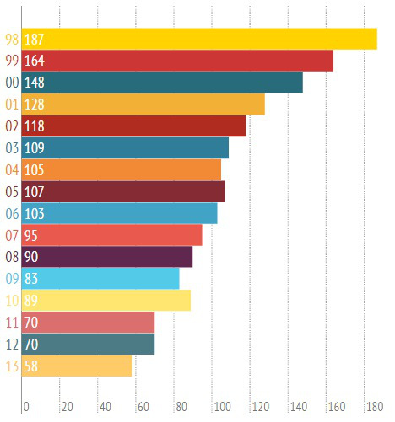

Even as the county has grown to 2 million residents, measures taken by the County over the past 20 years have sharply reduced the number of youth in detention. King County’s creation of alternatives to detention and improved court practices helped cut the number of youth in detention by more than 60 percent, bringing it from a high of 205 youth in 2000 to a low of 45 youth in 2014. On average, only about a quarter of the 212 detention beds at the Youth Services Center are filled.

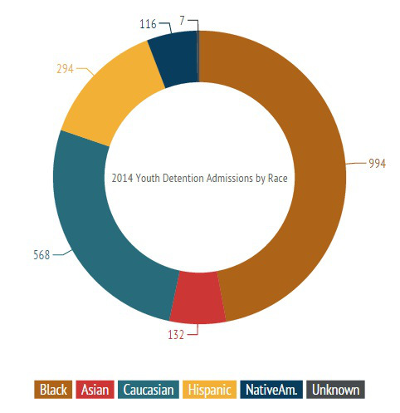

But as the overall number of youth in detention went down, the proportion of black youth in detention went up. About 10 percent of King County’s youth population is black, but they make up almost half of the youth detention population. Black youth are not benefiting from King County’s work to reduce the detention population as much as others.
Several efforts to tackle this disproportionality are underway. King County Superior Court is reforming youth probation. Restorative Mediation and Creative Justice programs collaborating with the King County Prosecuting Attorney’s Office launched this year. King County, school districts, cities, police departments and communities will need to work together on this mission to deliver true, equitable justice to all of our youth.

